“Bericht: Drehschwingungen von Melisa Bingöl, Matrikelnummer: 10027774”
- Computerprogramm Verwendung von Qti-Plot für das fitten der Messergebnisse im Protokoll
- Graphiken
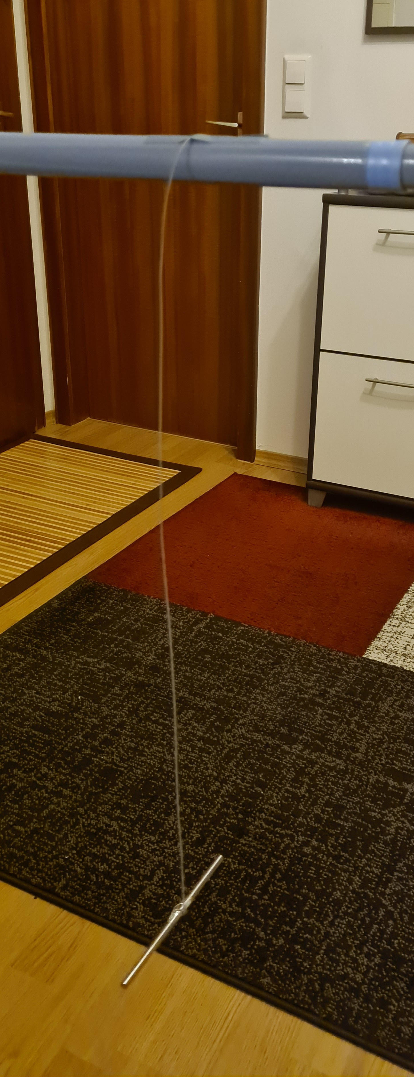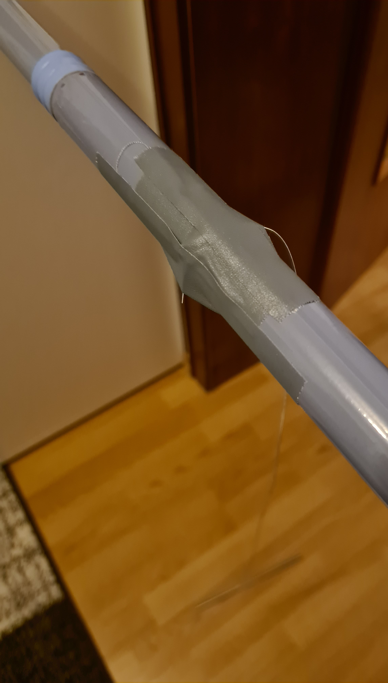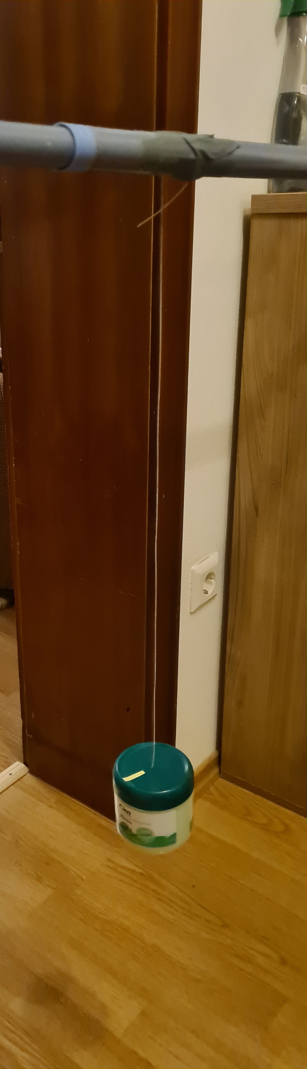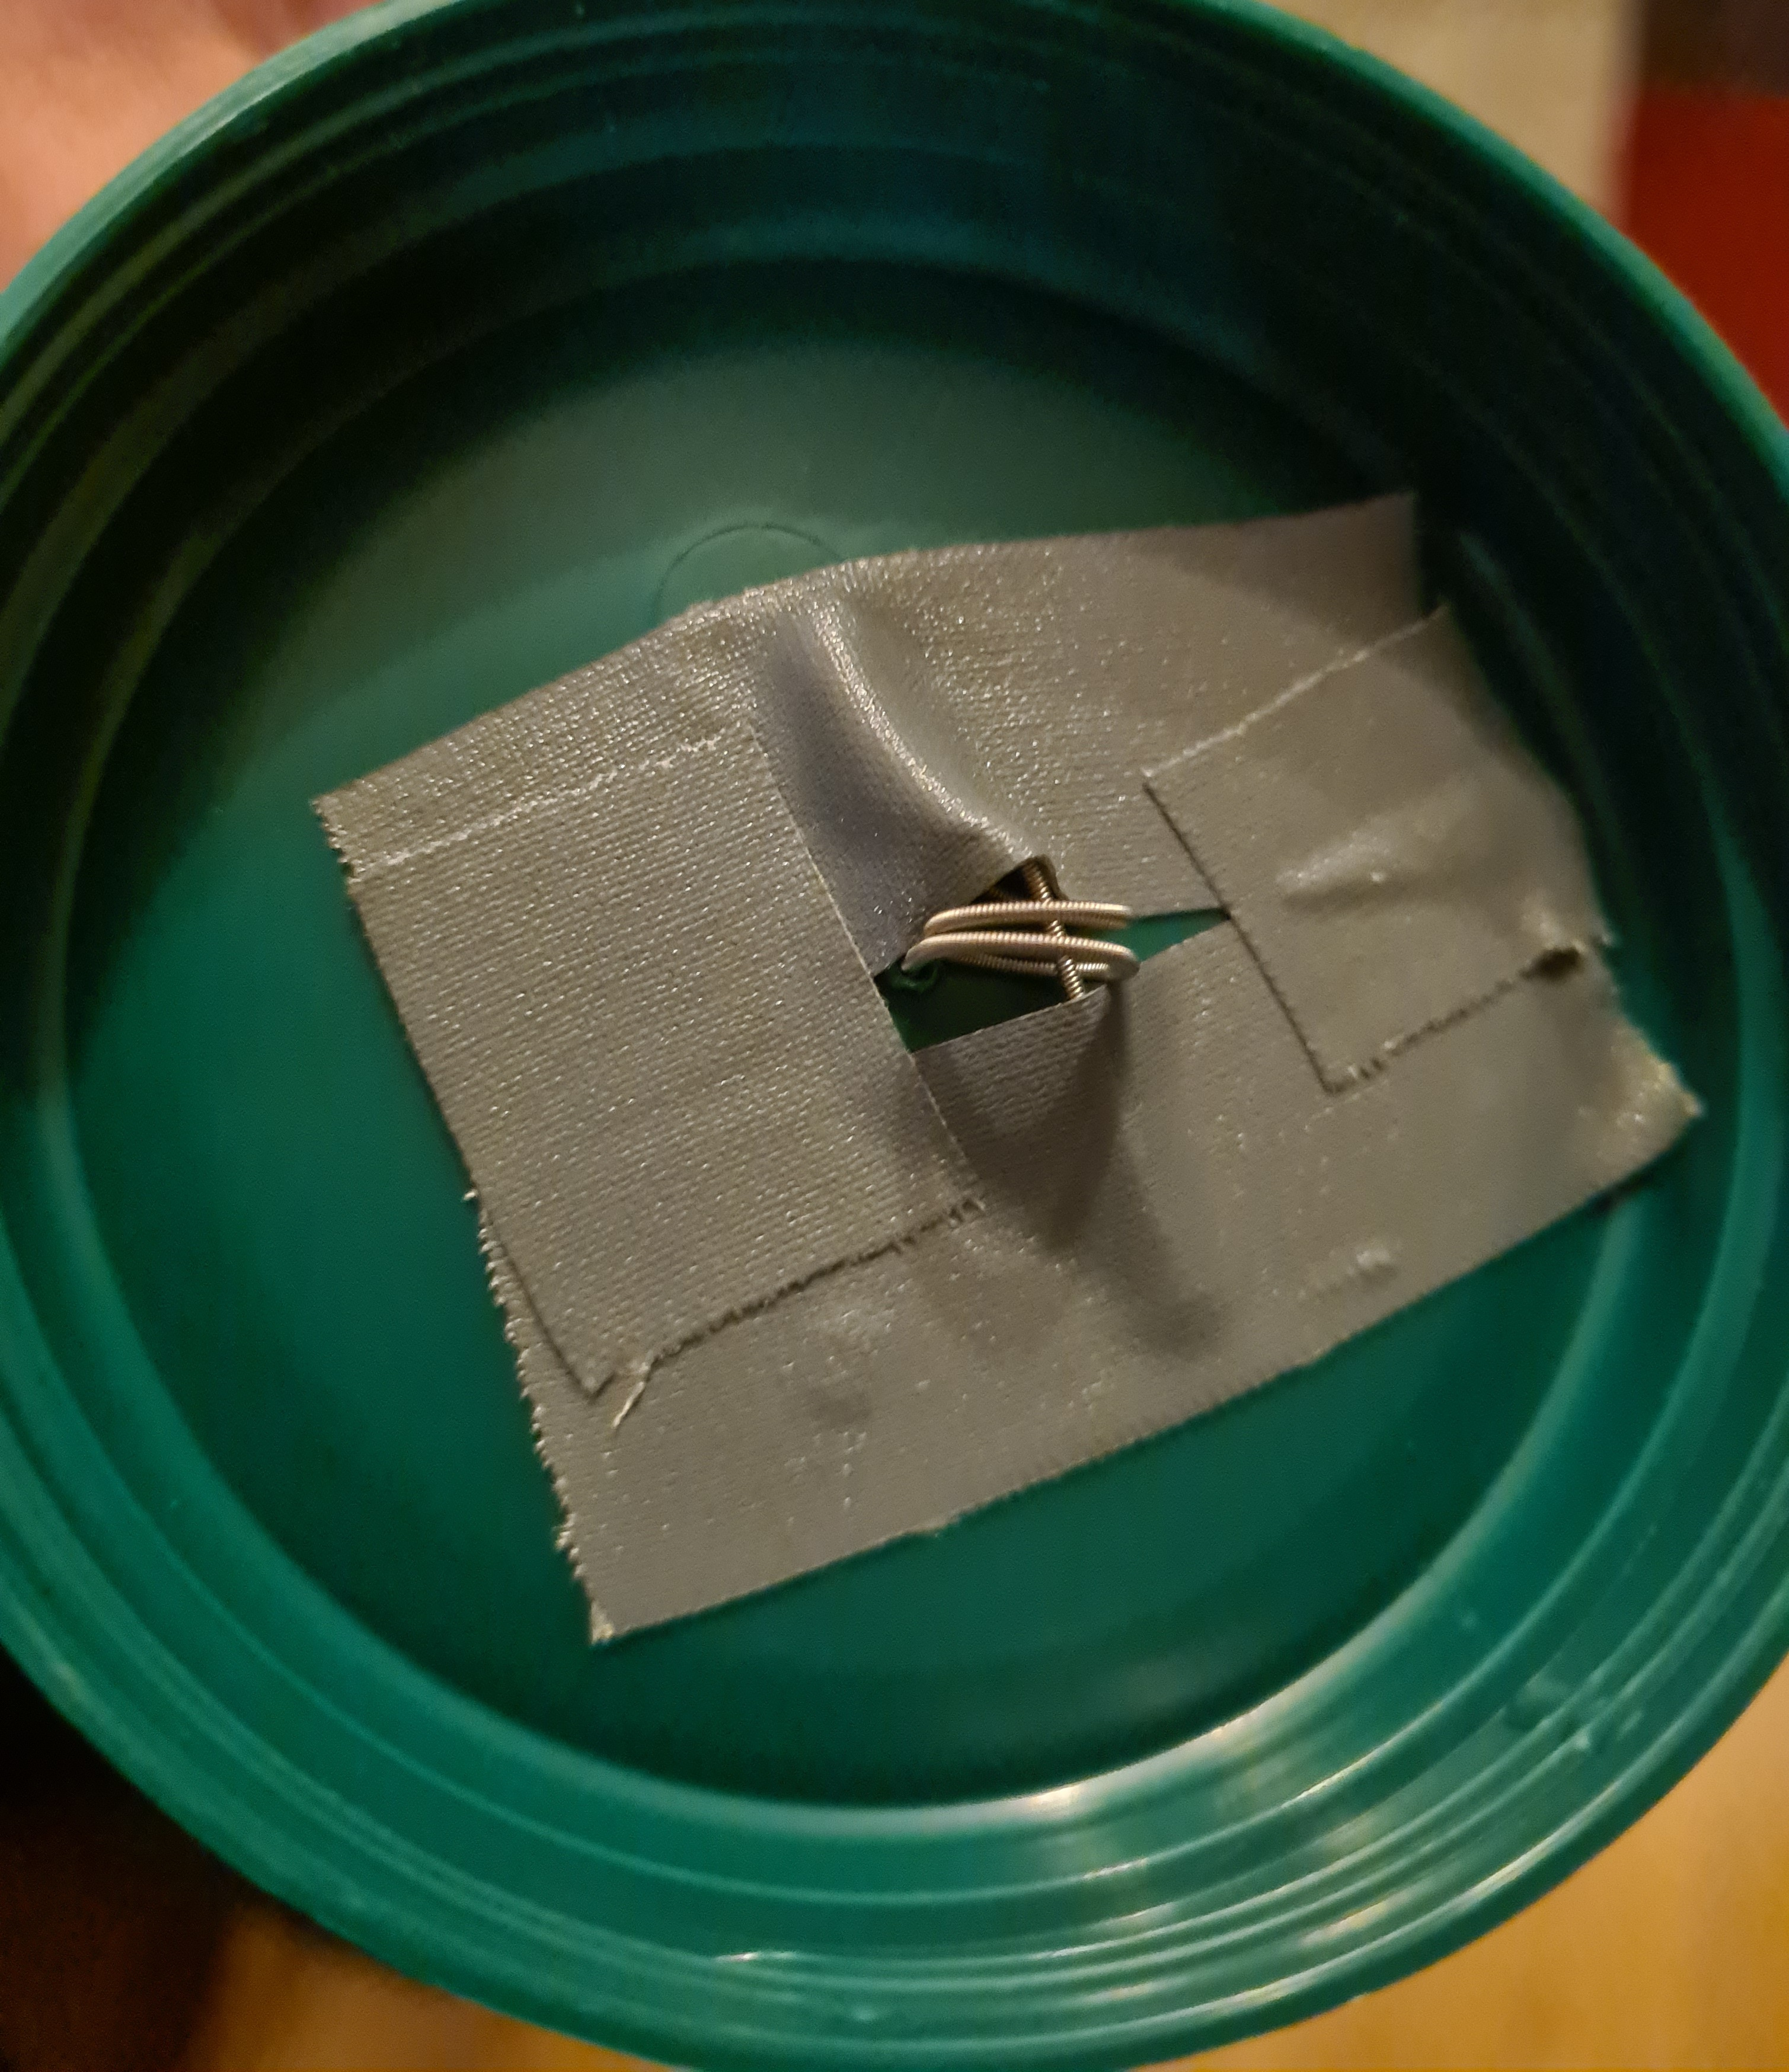
- Messwertetabellen
^ ^ L= 0,6 m | L=0,5 m | L= 0,4m | L= 0,3 m | L= 0,2 m |
Messwert-Nr. | T in s | T in s | T in s | T in s | T in s
1 | 1,76s | 1,47s | 1,41s | 1,14s | 1,02s
2 | 1,95s | 1,38s | 1,3s | 1,18s | 0,91s
3 | 1,59s | 1,47s | 1,34s | 1,13s | 1,02s
4 | 1,96s | 1,5s | 1,32s | 0,94s | 1,01s
5 | 1,9s | 1,51s | 1,27s | 0,81s | 0,9s
Mittelwert T in s | 1,832s | 1,466s | 1,328s | 1,04s | 0,972s
G in GPa | 5,325 | 6,930 | 6,756 | 8,262 | 6,306
 | L= 0,6 m | L= 0,5 m | L= 0,4 m | L= 0,3 m | L= 0,2 m
Messwerte-Nr. | T in s | T in s | T in s | T in s | T in s
1 | 3,96s | 3,31s | 3,61s | 2,9s | 2,32s
2 | 3,97s | 3,56s | 2,64s | 2,49s | 2,16s
3 | 3,73s | 3,13s | 3,04s | 2,5s | 2,27s
4 | 3,75s | 3,45s | 3,44s | 2,84s | 2,51s
5 | 3,6s | 3,12s | 2,96s | 2,2s | 2,45s
Mittelwert T in s | 3,802s | 3,314s | 3,138s | 2,586s | 2,342s
G in GPa | 58,957 | 64,666 | 57,698 | 63,720 | 51,792

